The Dark Side of Customer Analytics

Group 13 – Adrian Teo, Chen Chu, Jing Chao, Kyaw Zin Naing, Akhil Glaison.

## Case Background

#### ShopSense

ShopSense is a grocery chain established in the United States. The business has its own in-house analytics team that uses their customer loyalty card data to conduct customer analytics. Through its analysis, they have developed several marketing programmes and approaches. One of its key approaches is to use a pattern-based method to issue coupons to its customers. For example, ShopSense had experimented with printing health advices based on the customers’ past and present buying patterns on the back of their purchase receipts. It was noted that ShopSense currently makes more money from selling its customer data than from selling meat.

#### IFA

IFA is an insurance company established in the United States. The business had recently purchased a sample of ShopSense’s customer loyalty card data (10 years’ worth) to determine the quality and reliability of the data. With just this data sample, IFA was able to discover actionable insights. For example, it discovered a strong correlation between purchases of unhealthy products and medical claims from its own customers. As a result, they conceived a low-premium insurance plan aimed at IFA customers who did no indulge. IFA intends to purchase customer data from ShopSense in an exclusive manner.

## Key Considerations

#### ShopeSense

ShopSense is concerned about its customer relationship. It fears that when the customers find out about the business deal with IFA, the customers will stop using its loyalty card. Thus, this will risk diluting and possibly even destroying the relationship with its customers. However, they do not have any intention of revealing this business deal with IFA, and neither does IFA intend to.

#### IFA

IFA is optimistic about the advantages behind possessing ShopSense’s data and using it to develop new actionable insights. By coming into an exclusive deal with ShopSense, IFA will be able to formulate proprietary health indicators which may not be easy for competitors to replicate. In addition, using ShopSense’s data, IFA is able to accurately segment their customers. This allows IFA to target customers with marketing tactics that is tailored to their requirements, maximises IFA’s profit margins and reduces its associated risks. IFA also considers the legality of this business deal, and is assured that the exchange of data between ShopSense and IFA is legal.

## Commentaries

#### David Norton, Senior VP Relationship Marketing, Harrah’s Entertainment

Firstly, Norton believes that customers should know what they will get for allowing their data to be used. He firmly believes that businesses should let customers know about the value proposition up front. Secondly, Norton believes that customers’ data must be protected by setting appropriate rules for the utilisation of the data. Lastly, concerning public relations, Norton believes that customers’ potential responses must be evaluated, as well as the potential downstream issues that may arise.

#### Michael B. McCallister, President and CEO, Humana

McCallister believes in similar customer relations issues as Norton. Firstly, he believes that businesses must be transparent with the customers. Customers must be allowed an opt-in option. Secondly, McCallister believes that security measures must be taken to ensure that customers’ data are protected. Lastly, he believes that the decision to sell customers’ data without their knowledge is an ethical one, and must start from the CEO.

#### George L. Jones, President and CEO, Borders Group

Jones is of the perspective that just because the business is legal, and customers do not know about the deal, it does not mean that it is a valid marketing opportunity. Jones believe that ShopSense must be the ultimate custodian of its customers’ data. He also believes that the insights yielded from the data analysis may not be as accurate as the case makes it out to be since there is a key difference between purchasing and consuming the items.

#### Katherine N. Lemon, Assoc. Professor Marketing, Carroll School of Management, Boston College

Lemon believes that the unintended and uncontemplated use of customer data will erode trust, and this will affect the effectiveness of customer analytics. Businesses should engage in trust-building activities such as giving customers the option to opt-in, and to ensure customer data privacy. Lemon introduces a unique perspective – the Battered Customer Syndrome. Essentially, this syndrome sees the lack of interaction with customers on the lower end of the lifetime value spectrum. Lastly, Lemon also believes that the conclusion drawn from the data may not be conclusive due to the differences between purchaser and consumer.

## Thoughts and Implications

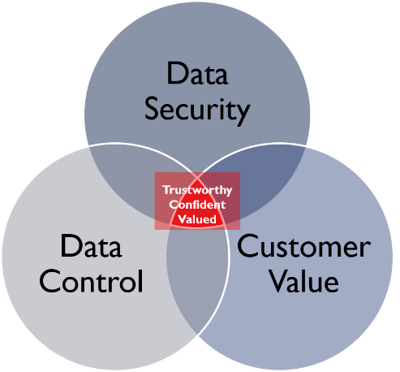Having read the case and commentaries, the team has come to learn that customer analytics alone is not enough to ensure customer relationships that are profitable to the business. There are three key aspects to it, mainly: Data Security, Customer Value and Data Control (See Diagram 1).

Diagram 1: Three Key Aspects of Customer Analytics Approach

Data Security. Customers’ data must be protected and secured by the company in order for customers to have confidence in the business.

Customer Value. Company’s customer analytics must prioritise creating value for the customer in order for customers to “stick”.

Data Control. Customers should be able to decide whether it is to be used for commercial reasons. This builds trust with the business.

The Sweet Spot. To ensure a balance between ensuring loyal customer relationships and business profitability, there is a need for customer analytics to strike a balance between Data Security, Data Control and Customer Value. Only with the inclusion of all aspects will the customer feel (i) confident about the business’ ability to keep their data secured and safe, (ii) that the business is a trustworthy entity that respects customers’ data, and (iii) that they are highly valued by the business.

## Conclusion

In order for businesses to thrive with customer analytics, all three aspects are important. The confluence of these three factors will ensure that the customer (i) Believes the business to be **trustworthy** such that the business will not abuse the customers’ data, (ii) Has great **confidence** in the business’ ability to ensure that the customers’ data is protected and secured from potential cyber malice, and (iii) Understands that the business is focused on creating **value** primarily for the customers.